(Approx. 400 words)

Review: Honey App
Judy Taylour, President, SCV Computer Club
www.scvcomputerclub.org
scvcomputerclub (at) gmail.com

Do you use the Honey app when you shop online? I do. It even works at Amazon.

I imagine there are many members who remember White Shoulders – one of my favorites and I still use it. I buy it at Fragrance.net. When giving hugs at church I sometimes hear….you smell just like my mother did ;-).

About Us
FragranceNet.com has been trusted online since 1997. We have shipped over 20 million packages and have sold over $1 billion in beauty products. We carry 17,000 genuine, brand name fragrances, skincare, makeup, haircare, aromatherapy and candles all at discount prices. We offer Free Shipping in U.S. with a minimum order. FragranceNet.com has received an A+ rating from the Better Business Bureau.
(Stock Symbol: FGNT.PK)
I received an email that White Shoulders was on sale, so I took a look. I only buy White Shoulders so those are the only emails I receive. On another site, it was $22 for the spray cologne with no discount or Honey coupon available.
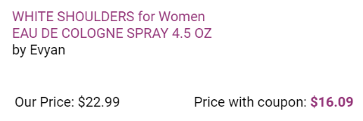

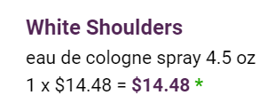
When the Honey coupon was applied, it ended up being a total of 37% off. There is shipping and tax; sometimes shipping is free with the promotion or by the amount of sale. I didn’t pay shipping (I bought more than one).

On another purchase, I saved a lot when purchasing two (what I call teacher carts—I had one for each class I taught) carts for the senior center bingo volunteers to use. They cost $29.99 each and were on sale at Staples for $24.99. With my teacher discount they were $20.99 and with the Honey discount, I paid $15.99 for each cart.

After starting this article, I checked my email and had received one from a store where I buy t-shirts. They were having a 10% off sale; with the Honey coupon I saved $17.00. $49 before 10% off / paid $32. They were two shirts I wanted but only on sale.
I have a PayPal account and use it when I shop. Don’t use your Debit card and don’t ever buy anything online unless you see this in the address line.

Apprehensive about shopping on line? Use a credit card with a low limit, one where you receive alerts when it is used, or a virtual card (as of April 2019 - America, Capital One and Citi).

